Toolbox
Where to find and how to search for exercises
All exercises are uploaded onto our online database called Toolbox. The Toolbox includes a set of various social literacy exercises for use with individuals and groups. The exercises cover various topics but they all aim to enhance social literacy skills to develop a workshop on this subject.
You can easily get access to the Toolbox by clicking on the following link: http://toolbox.social-literacy.eu/. Use the materials provided on our online platform, referred to as Toolbox, in any setting or reasonable combination with your own exercises.
You may use the Search Form (see the picture below) to search for exercises that fit your search criteria such as modules, language, group size, duration. Just select the appropriate search criteria (one or more).
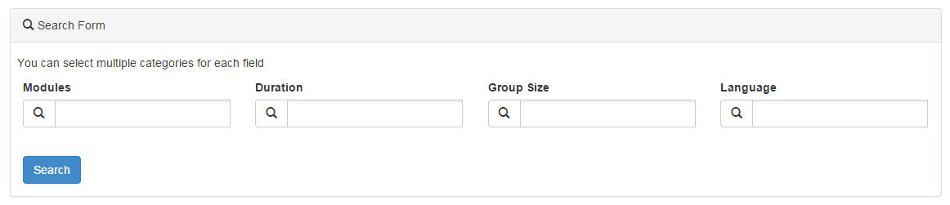
Then, click on the search button and the exercises that match the search criteria will appear (Search Results).
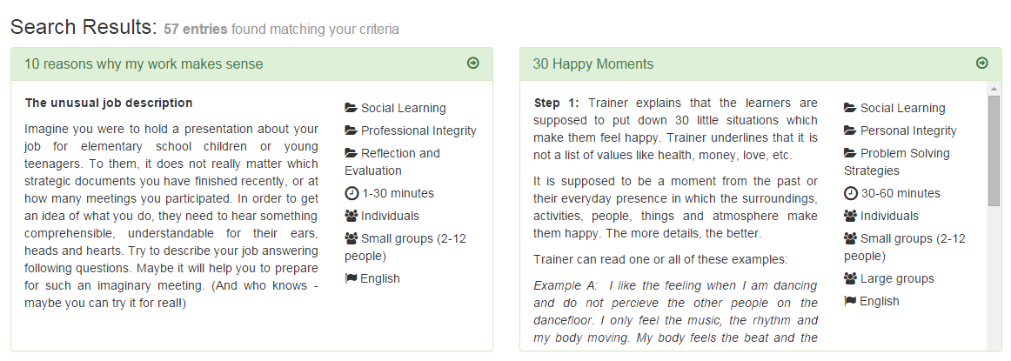
Click on an exercise title to view the specific exercise. You are prompted to login in order for the full exercise to appear.
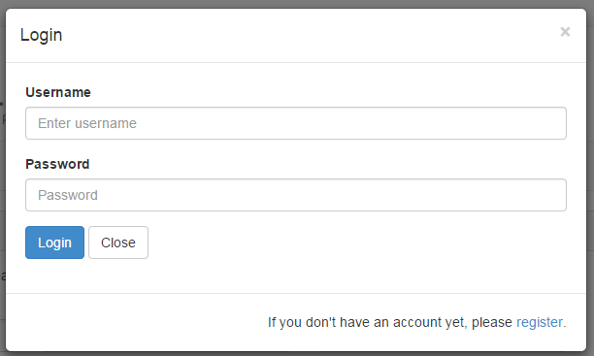

If you do not have an account, please register first.
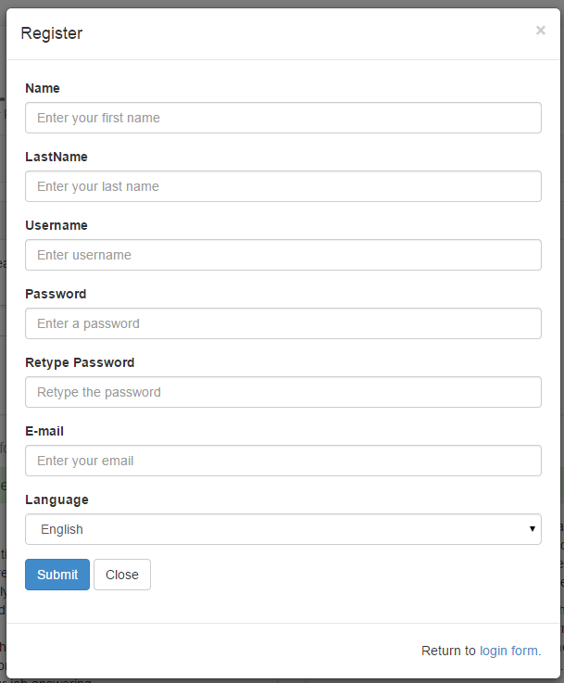

After logging in, you can view the full exercise.
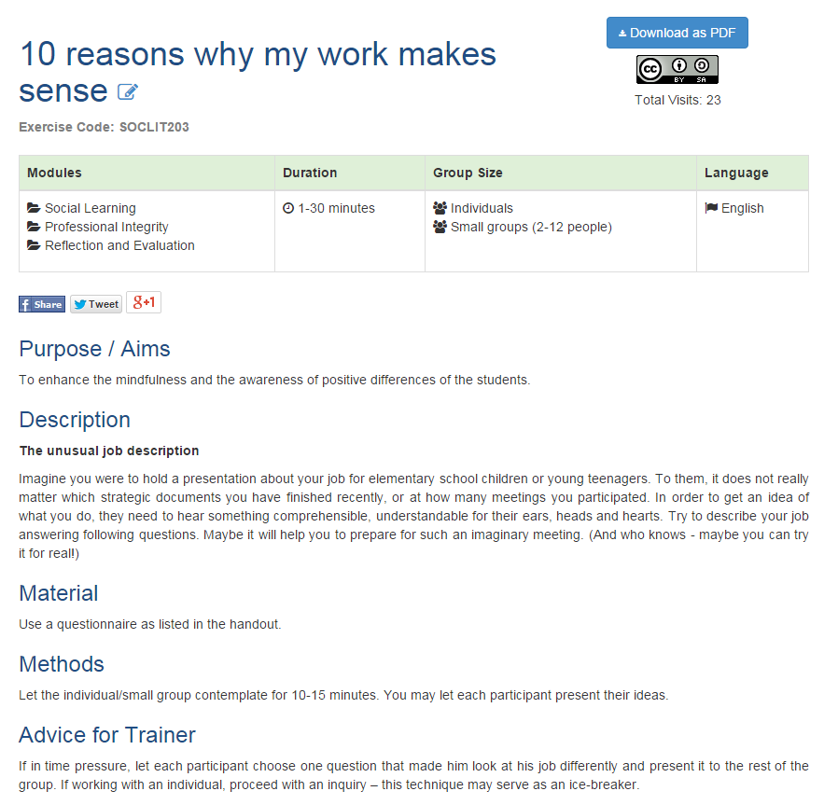
You can also download the exercise as a pdf file.
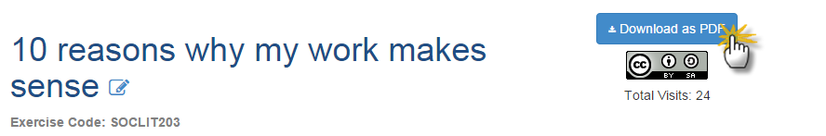

Creative Common License
All materials provided on the Toolbox are licensed under a specific Creative Commons license, Attribution - Share Alike 4.0 International (CC BY-SA 4.0). This license lets others remix, tweak, and build upon our work, as long as they credit us and license their new creations under the identical terms. You may visit the CC’s site https://creativecommons.org/licenses/by-sa/4.0/ for more information.

