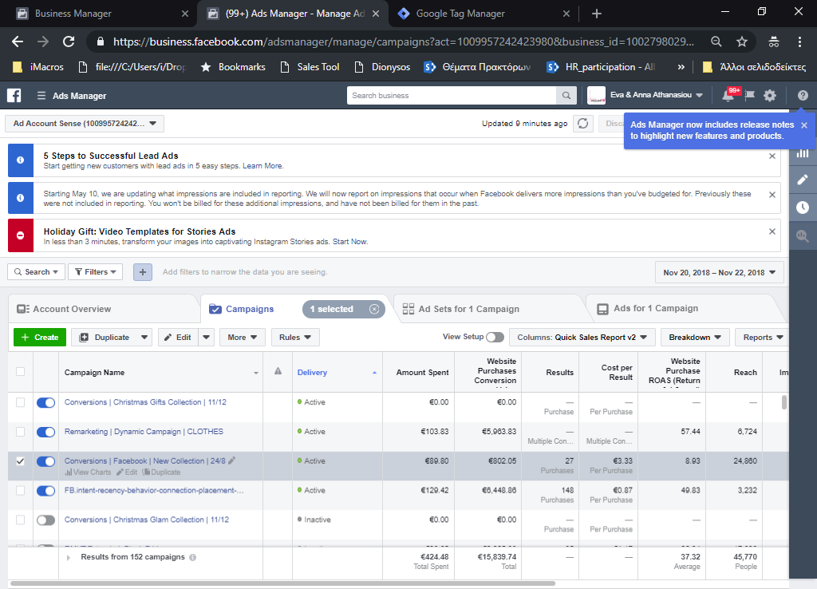

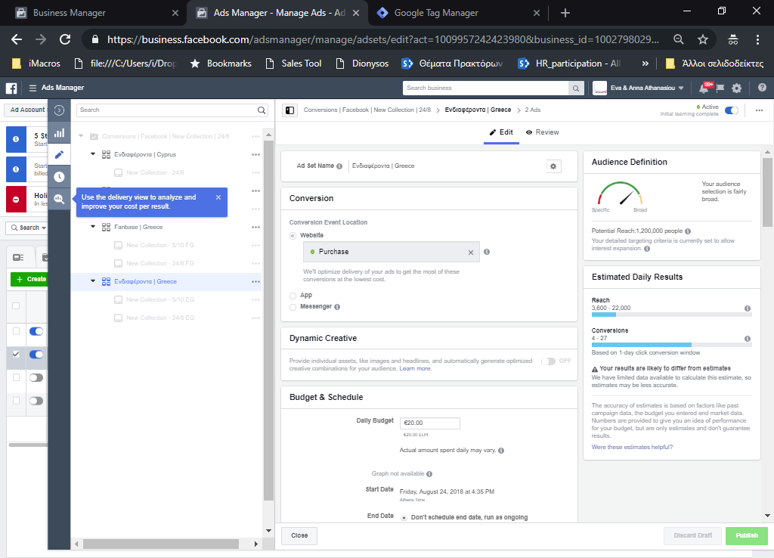



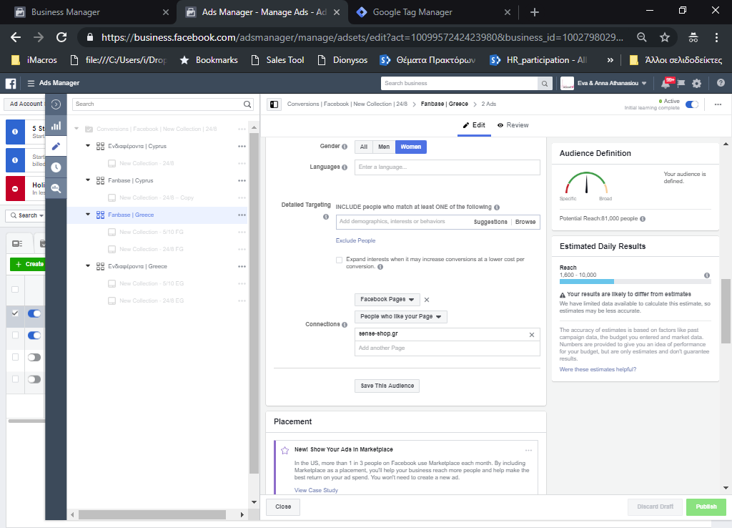

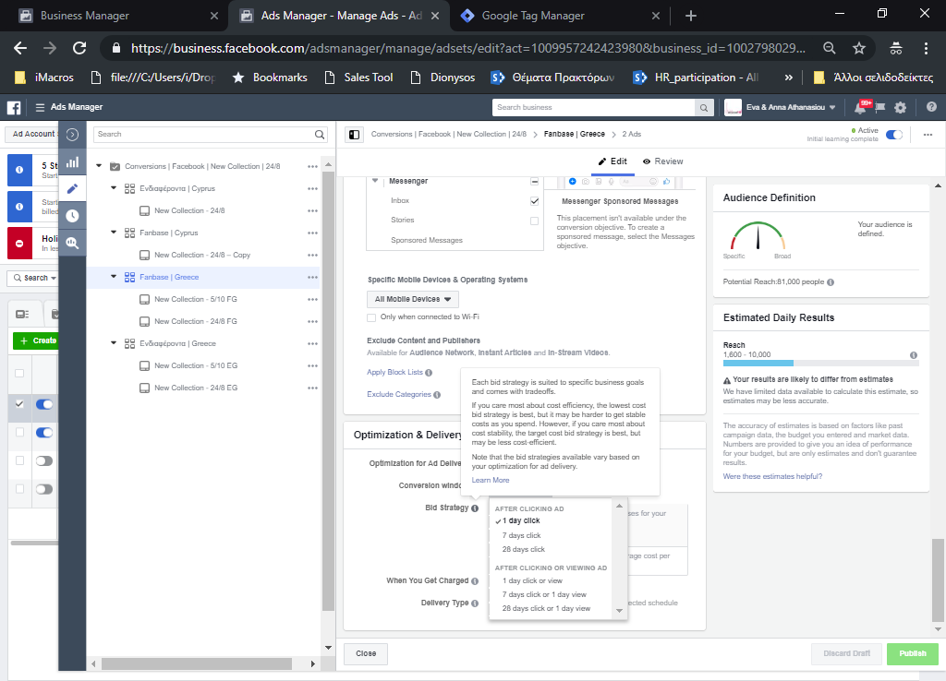

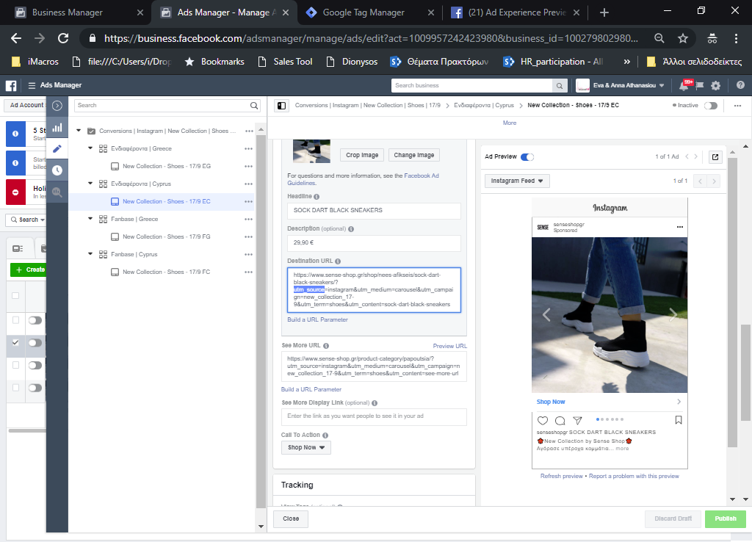

<https://ga-dev-tools.appspot.com/campaign-url-builder/>

Example

<https://www.sense-shop.gr/shop/nees-afikseis/sock-dart-black-sneakers/?utm_source=instagram&utm_medium=carousel&utm_campaign=new_collection_17-9&utm_term=shoes&utm_content=sock-dart-black-sneakers>

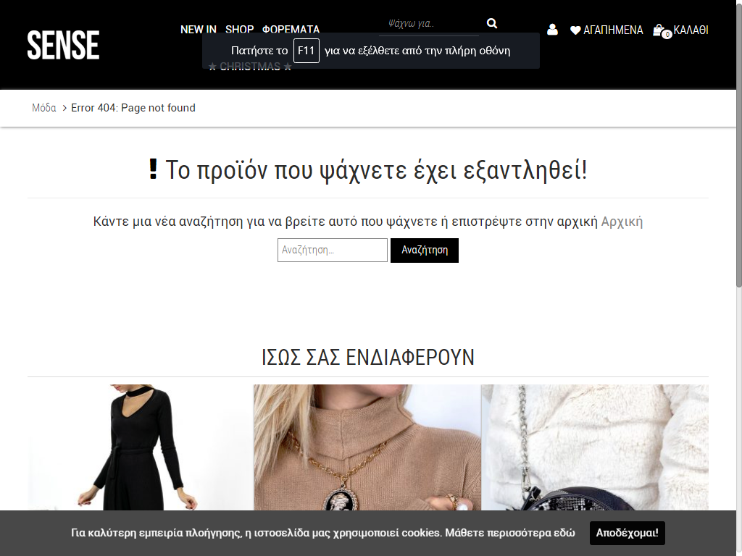

Parameter

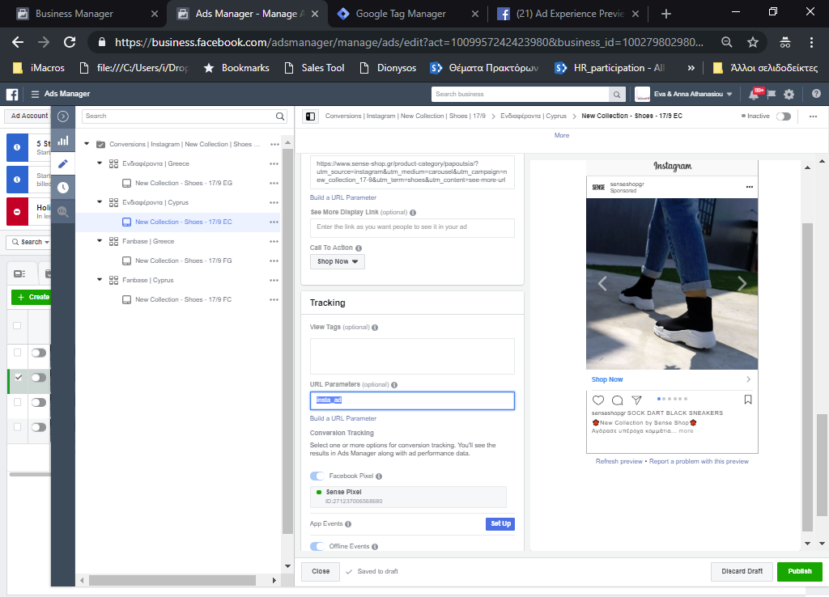

<https://www.driftrock.com/blog/differences-between-facebook-ads-manager-and-google-analytics-metrics>

