PC 3 UNIT 1 – Lesson 2: SCHOOL SUBJECTS
New words: Maths= Μαθηματικά, Language=Γλώσσα, Religion (R.E.)= Θρησκευτικά, Geography= Γεωγραφία, Science=Μελέτη Περιβάλλοντος, Art= Εικαστικά, Sports (P.E.)= Αθλήματα (Γυμναστική), History= Ιστορία, English= Αγγλικά, French= Γαλλικά, German= Γερμανικά

1. Lisa is from U.K. She goes to Merton Primary School in Liverpool. This is her timetable. Dou you have the same subjects at school?
 | Lesson | Monday | Tuesday | Wednesday | Thursday | Friday
09:00 | 1 | English | Maths | Science | English | Art
10:00 | 2 | Geography | Maths | Religion | English | French
11:00 |  | Break | Break | Break | Break | Break
11:30 | 3 | Religion | Geography | English | Geography | Sports
12:30 |  | Lunch | Lunch | Lunch | Lunch | Lunch
13:30 | 4 | French | Science | Maths | Sports | French
14:30 | 5 | History | History | History | Sports | Science
_____________________________________________________________________
2. CROSSWORDS School subjects
Find and circle the words for School subjects.

A | F | E | T | I | S | O | B | M | U | S | I | C | L | A | S | T | O | F | I
O | P | A | R | T | I | N | E | L | A | F | I | S | H | M | A | T | H | S | E
M | I | R | O | N | E | S | N | G | E | O | G | R | A | P | H | Y | I | D | Y
S | O | P | I | N | E | F | G | I | U | S | S | A | N | P | E | L | S | I | M
P | H | Y | S | I | C | A | L | E | D | U | C | A | T | I | O | N | T | E | R
A | P | L | E | I | Z | E | I | B | A | L | I | T | I | M | E | I | O | S | U
R | O | D | A | R | M | U | S | A | I | P | E | A | L | P | R | C | R | O | L
T | R | E | S | P | U | A | H | F | L | A | N | G | U | A | G | E | Y | L | E
P | E | L | I | F | I | O | N | E | L | U | C | V | I | S | O | N | T | E | R
I | N | R | E | L | I | G | I | O | N | S | O | D | U | L | T | A | N | O | N

Which school subjects do/don’t you like?
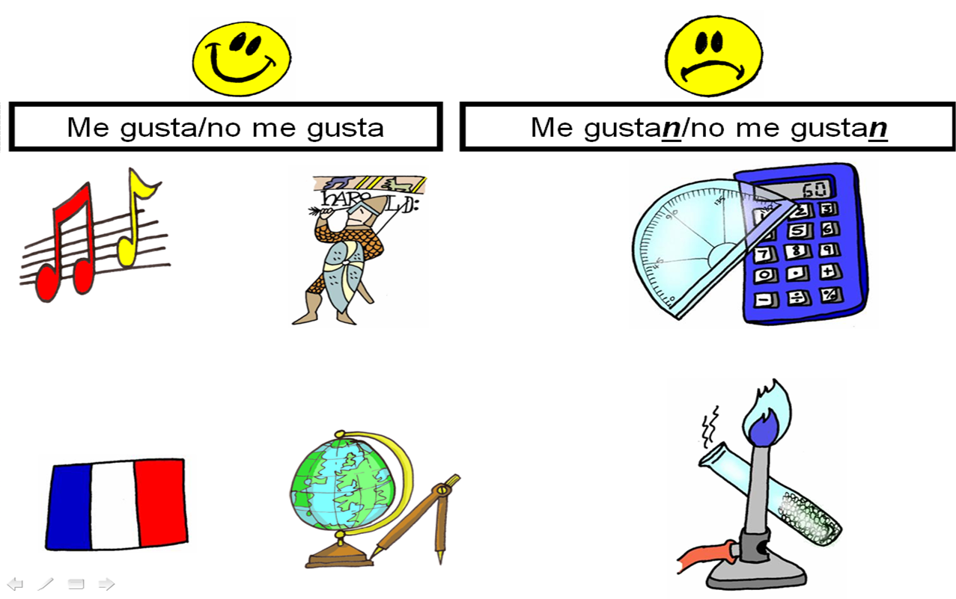
Use: I love/I like … because.. /I don’t like …very much/I hate …/Art is ok.
A favourite day

Look at Lisa and Omar’s new school timetable. Read their dialogue.

 | Lesson | Monday | Tuesday | Wednesday | Thursday | Friday
09:00 | 1 | English | Maths | Science | English | Art
10:00 | 2 | Science | Maths | Maths | English | French
11:00 |  | Break | Break | Break | Break | Break
11:30 | 3 | Religion | Geography | French | Geography | Sports
12:30 |  | Lunch | Lunch | Lunch | Lunch | Lunch
13:30 | 4 | French | Science | History | Sports | History
14:30 | 5 | Religion | English | History | Sports | Geography

Omar: Hi, Omar. How do you like our school timetable for this year?
Lisa: I think it’s OK. We’ve got new subjects, Science and French, which are quite interesting, but I prefer History, because we learn a lot about ancient Greece and its people. What’s your favourite subject this year?
Omar: Well, I enjoy learning about different countries and peoples, so for me Geography is the best, but I also like Maths and English. I hate French!
Lisa:. So, I suppose your favourite day is …
Omar: And yours is …

1. What’s Lisa’s favourite day? Monday Tuesday Wednesday Thursday
2. What’s her favourite subject? Science French Maths History
3. What’s Omar’s favourite day? Monday Tuesday Wednesday Friday
4. What’s his favourite subject? Maths English Geography French

KEY

A | F | E | T | I | S | O | B | M | U | S | I | C | L | A | S | T | O | F | I
O | P | A | R | T | I | N | E | L | A | F | I | S | H | M | A | T | H | S | E
M | I | R | O | N | E | S | N | G | E | O | G | R | A | P | H | Y | I | D | Y
S | O | P | I | N | E | F | G | I | U | S | S | A | N | P | E | L | S | I | M
P | H | Y | S | I | C | A | L | E | D | U | C | A | T | I | O | N | T | E | R
A | P | L | E | I | Z | E | I | B | A | L | I | T | I | M | E | I | O | S | U
R | O | D | A | R | M | U | S | A | I | P | E | A | L | P | R | C | R | O | L
T | R | E | S | P | U | A | H | F | L | A | N | G | U | A | G | E | Y | L | E
P | E | L | I | F | I | O | N | E | L | U | C | V | I | S | O | N | T | E | R
I | N | R | E | L | I | G | I | O | U | S | E | D | U | C | A | T | I | O | N

